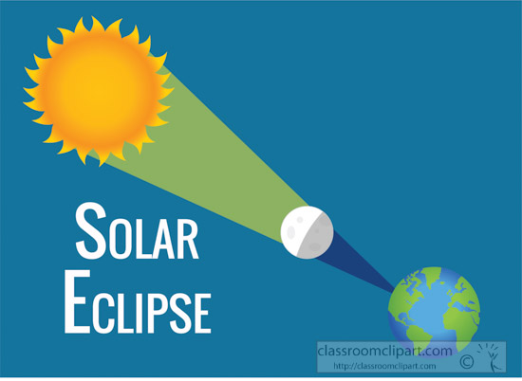

Mayor Galea has called for a work session on Tuesday, January 30, 2024 at 6:00pm, in the Council Chambers of the MMC, for the purpose of making plans for the April 8th solar eclipse event.

